Project Methodologies
This methodology uses a linear approach. Whereby each stage is completely executed before going to the next stage.
Stages:
- Requirement Analysis
- System Design
- Implementation
- Testing
- Deployment
- Maintenance
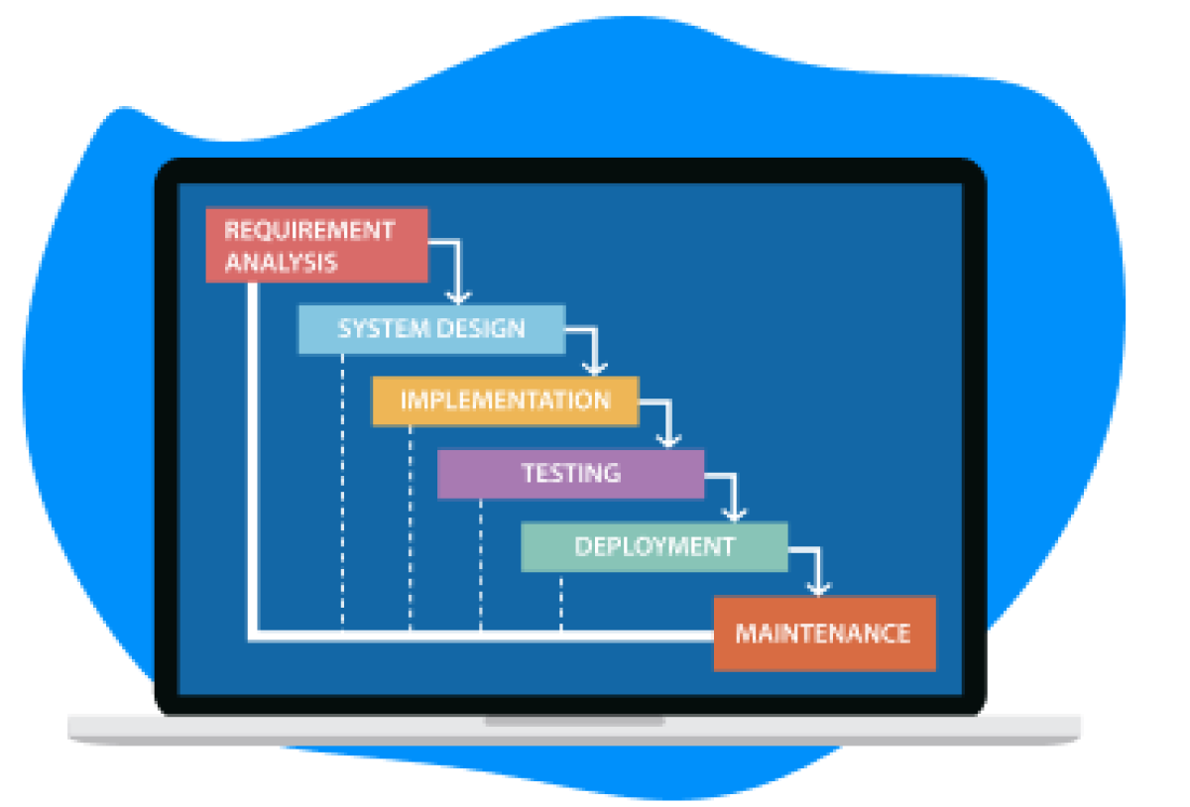

Project Use Model

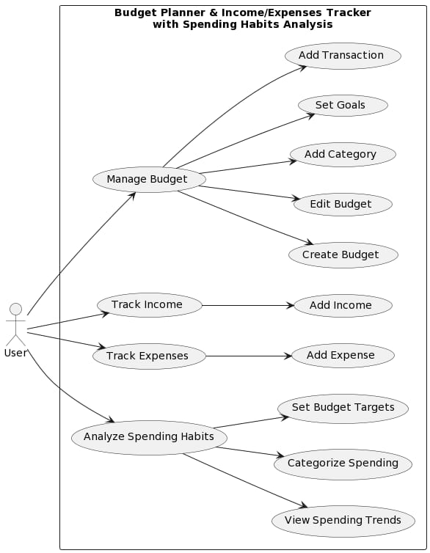
System Modelling
Context Model
User Interface represents the graphical interface of the PennyWise app, which allows users to interact with the system and access its various features. The model has 4 features;

- Income Tracking System: This component represents the system within PennyWise that allows users to track their income and monitor their earnings over time.
- Expense Tracking System: This component represents the system within PennyWise that allows users to track their expenses and monitor their spending over time.
- Budget Management System: This component represents the system within PennyWise that allows users to set and manage their budget, including setting goals, creating savings plans, and tracking progress.
- Behavioral Analysis System: This component represents the system within PennyWise that uses machine learning algorithms and data analytics to analyze user behavior and provide personalized recommendations

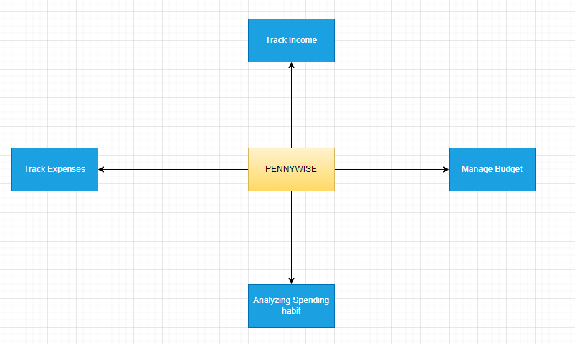

Interaction Model
The interactions between the user and the system are represented as arrows in the diagram below.The user performs the following actions:
- Logs in- to access the application's features.
- Adds Expense - to add an expense to their budget and track their spending.
- Views Expenses - to view their expenses.
- Analyzes Spending Habits- to review their spending habits.
- Sets Budget - to set a budget for their expenses.
- Tracks Income - to track their income.
- Exports Data- to export their budget and spending data.
- 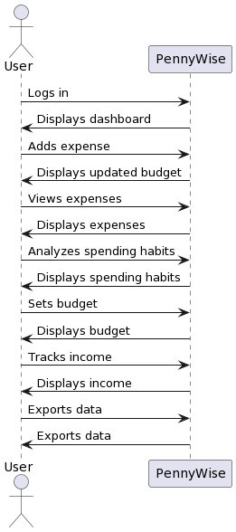

Structural Models
Class Diagram
The PennyWise class represents the app as a whole, with attributes for the user, the financial data, and the behavior analyzer, and methods for tracking income and expenses, managing budgets, and analyzing behavior.

The relationships between the classes are represented by associations, which indicate how instances of one class can be related to instances of another class. For example, the PennyWise class has associations with the User, Income, Expense, Budget, and Behavior Analyzer classes, which means that instances of these classes can be associated with instances of the PennyWise class.
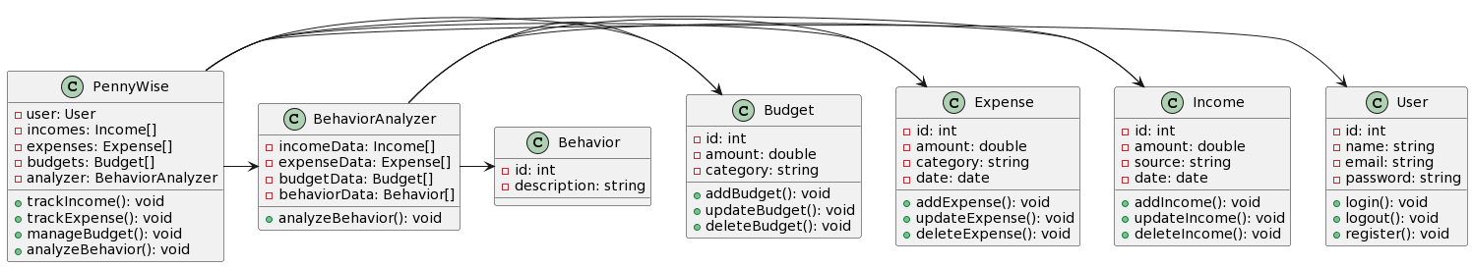

Behavioral Model
Data Flow Diagrams
This DFD shows the major components of the PennyWise Budget Planner App, including the Income Tracker, Expense Tracker, Budget Management, and Behavioral Analysis features. The User interacts with each of these components to add, view, edit, or delete information related to their budget.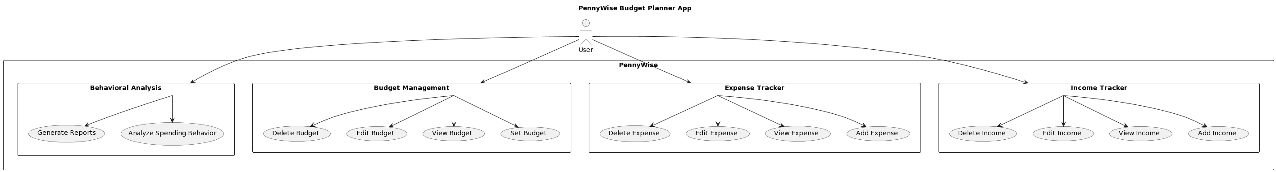

Flowchart Diagram

